Rules for Sig Figs:
- All non-zero digits are significant
-Zeroes after the decimal point and a non-zero number are significant. (0.0020 -> 2 sigs)
-Zeroes between non-zero digits are significant
-Zeroes at the ends of numbers punctuated by a decimal point are significant. (200. -> 3 sigs, 200 -> 1 sig)
-When adding and subtracting, the sum or difference has to match the number of sig figs in the most concise number before the equal sign. (4.02 + 3.0 = 7.0) (3 sigs + 2 sigs = 2 sigs)
- Exact numbers (numbers without and decimal places) are treated as if they have an infinite number of sig figs for the purpose of calculations. (2.04 x 2 = 4.08) (2 sig figs + ∞ sig figs = 2 sig figs).
-When doing multiple simultaneous calculations, answers are always rounded at the end.
-When determining sig figs in scientific notation, look only at the actual number as if the “x 10^{y}” did not exist.
Questions for you benefit:

When performing the calculation 34.530 g + 12.1 g + 1 222.34 g, the final answer must have how many sig figs?
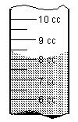
The volume of liquid being measured in the graduated cylinder is?

13.004 m + 3.09 m + 112.947 m = ?

What is the following measurement to three significant figures: 0.90985 cm²?

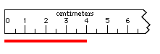
When measuring the length of this red line with the metric ruler provided, the first decimal place that is uncertain is?

345.009 g - 23.009 g = ?

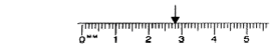
The arrow denotes what measured point?

The mass of a watch glass was measured four times. The masses were 99.997 g, 100.008 g, 100.011 g, and 100.005 g. What is the average mass of the watch glass?

How many significant figures are in the measurement 102.400 meters?

Convert the following measurement to scientific notation: 101 000 grams

Complete the following problem: A piece of stone has a mass of 24.595 grams and a volume of 5.34 cm³. What is the density of the stone? (remember that density = m/v)

